Ezeakudolu Chinemerem David

000778050

Lab 1

Lab Status: Based on the Lab instructions and the steps to follow in developing this lab everything is working correctly.

Three Things Learnt:

1. I learnt how to give access to different users based on the user roles .
2. I learnt how to edit the IdentityUser by creating a new class e.g ApplicationUser.
3. I learnt that it is a good practice to add migrations and update database when needed.

Three Things To Work On:

1. To work on given access to different pages.
2. Learn more about Asp.Net Identity
3. Learn more about the Data Type Annotation [DataType(DataType.DateTime)]

SCREENSHOT

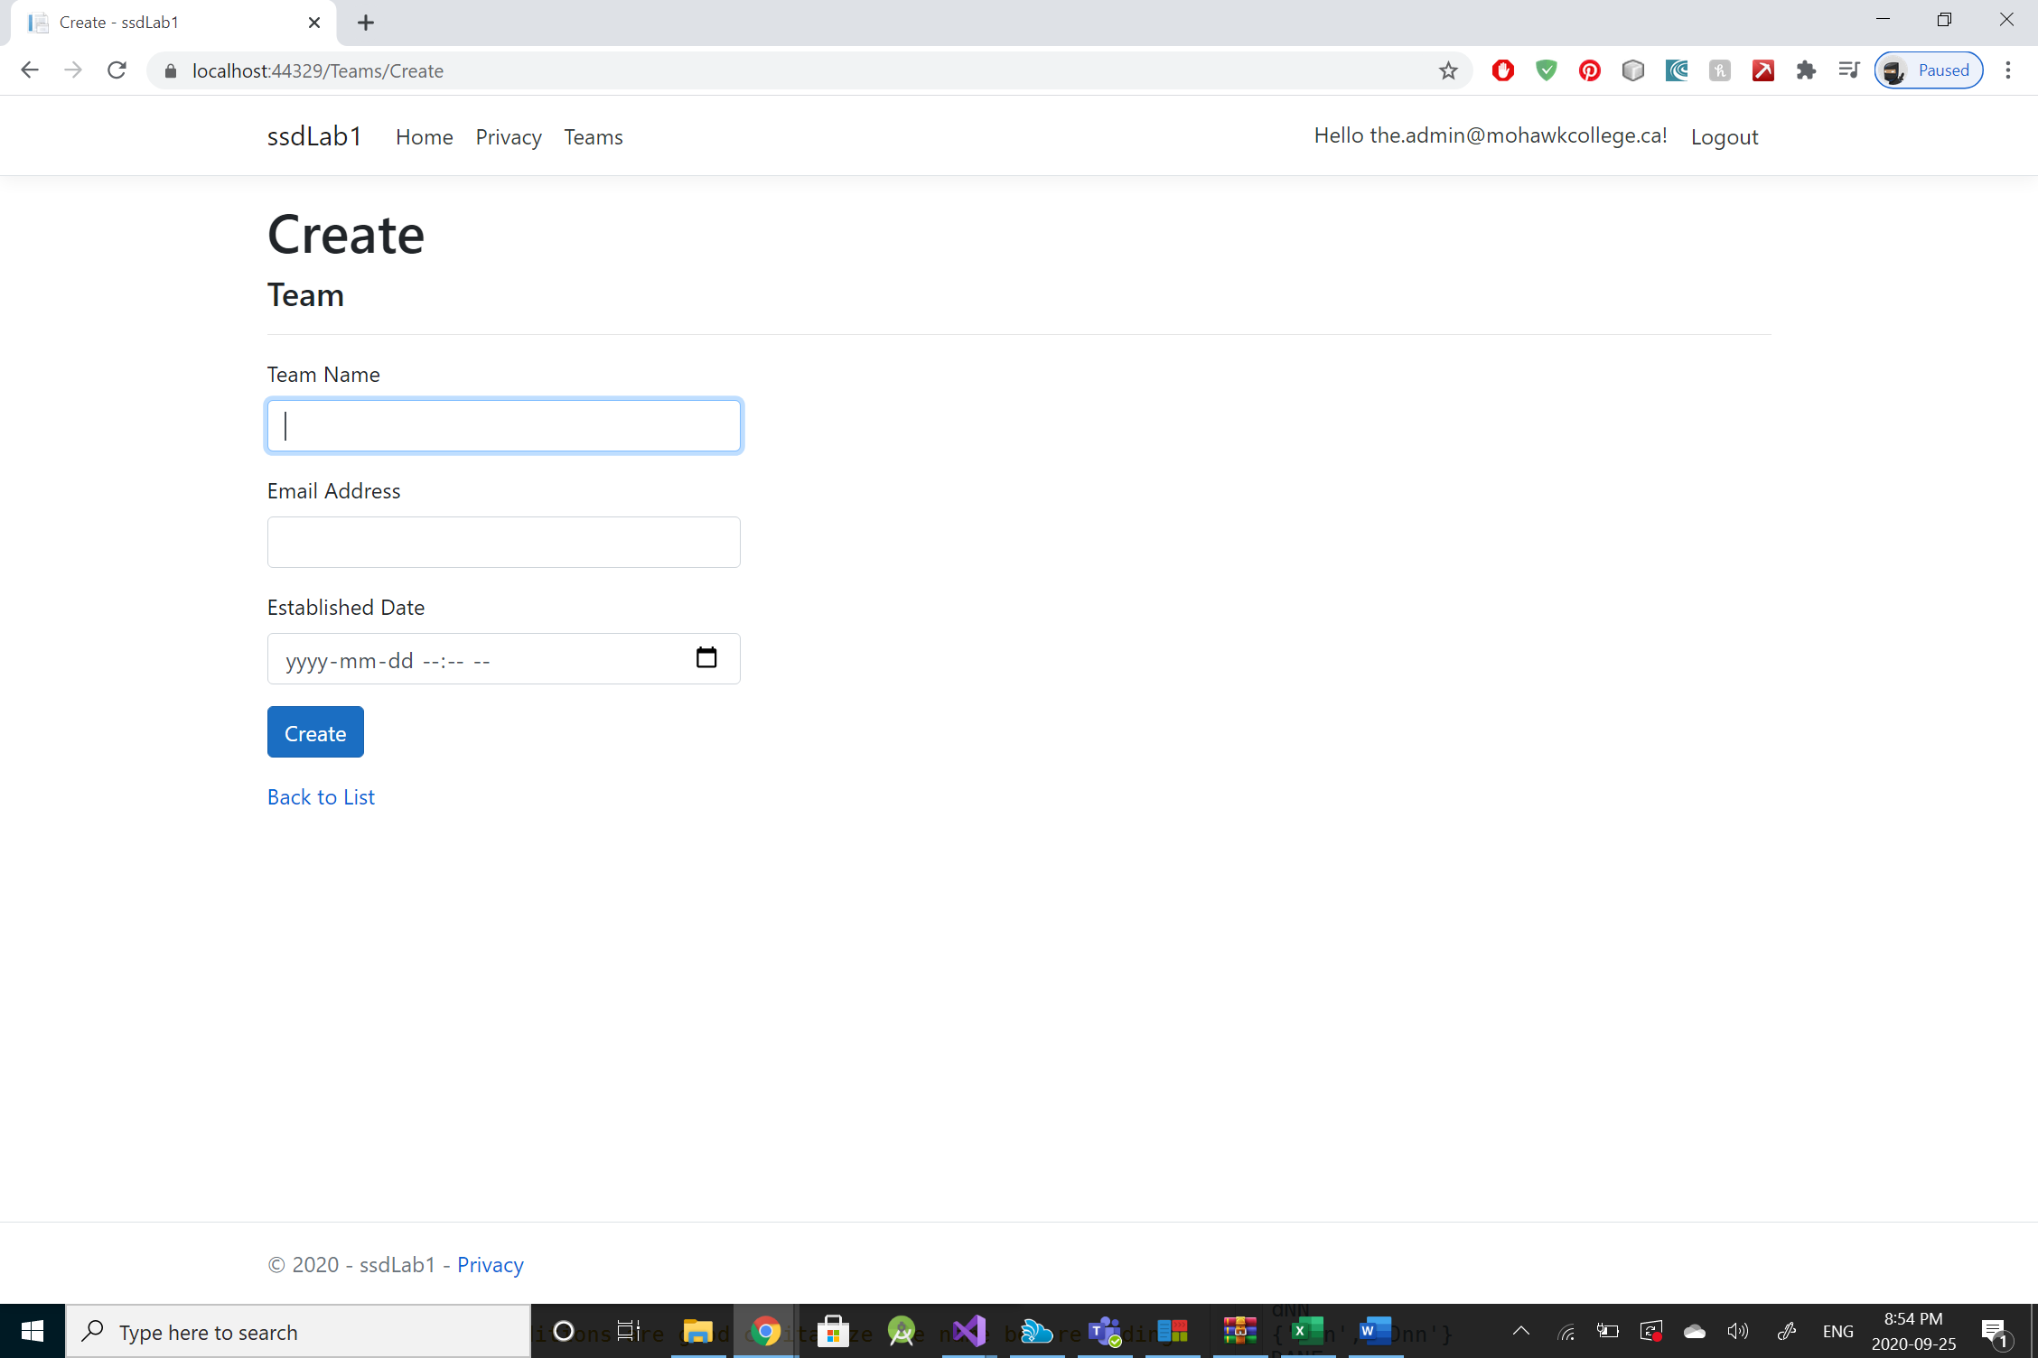

Figure 1 Create a new team instance Admin User

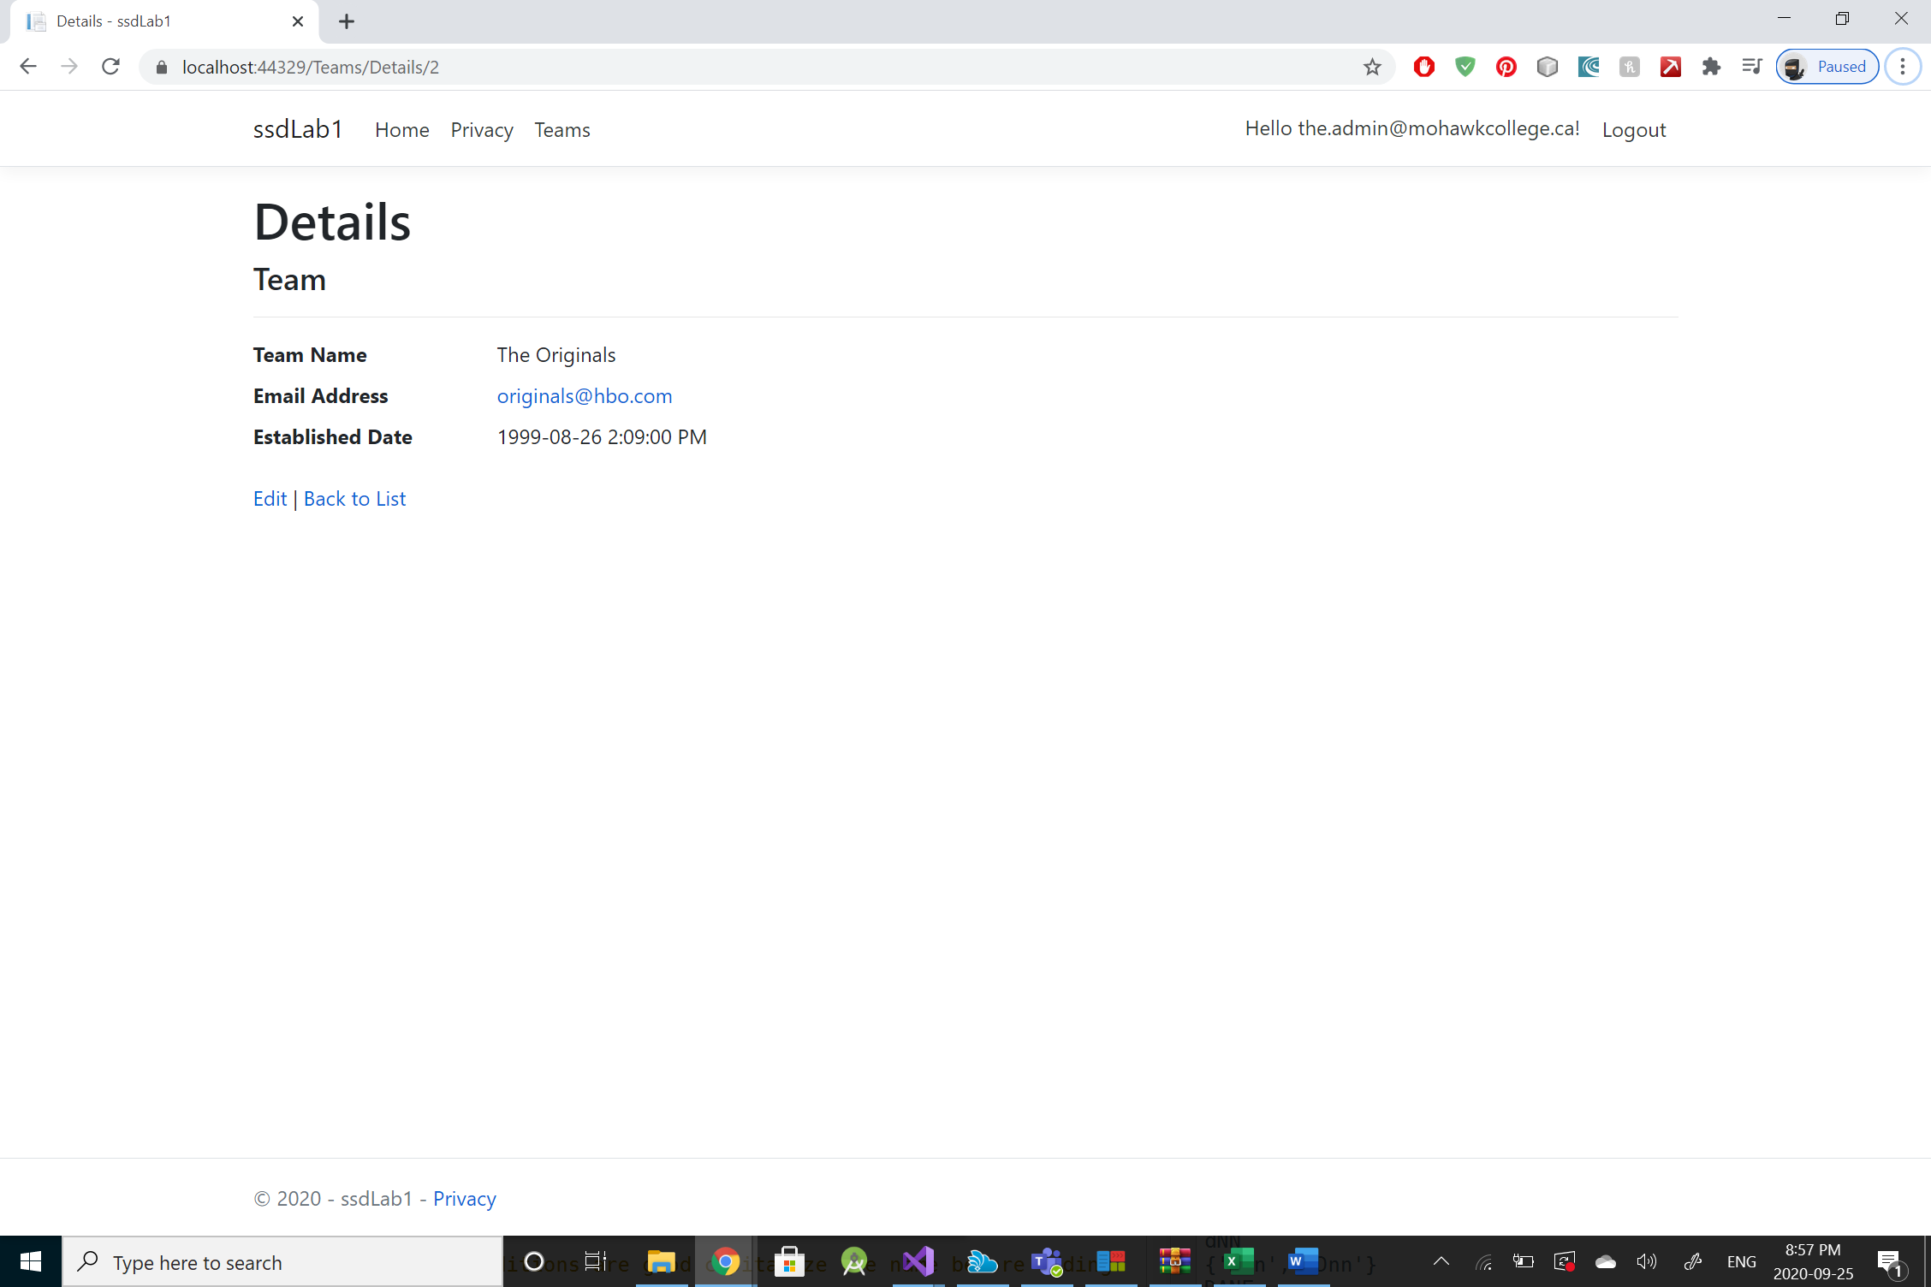

Figure 2 Detailed view of Team instance Admin User

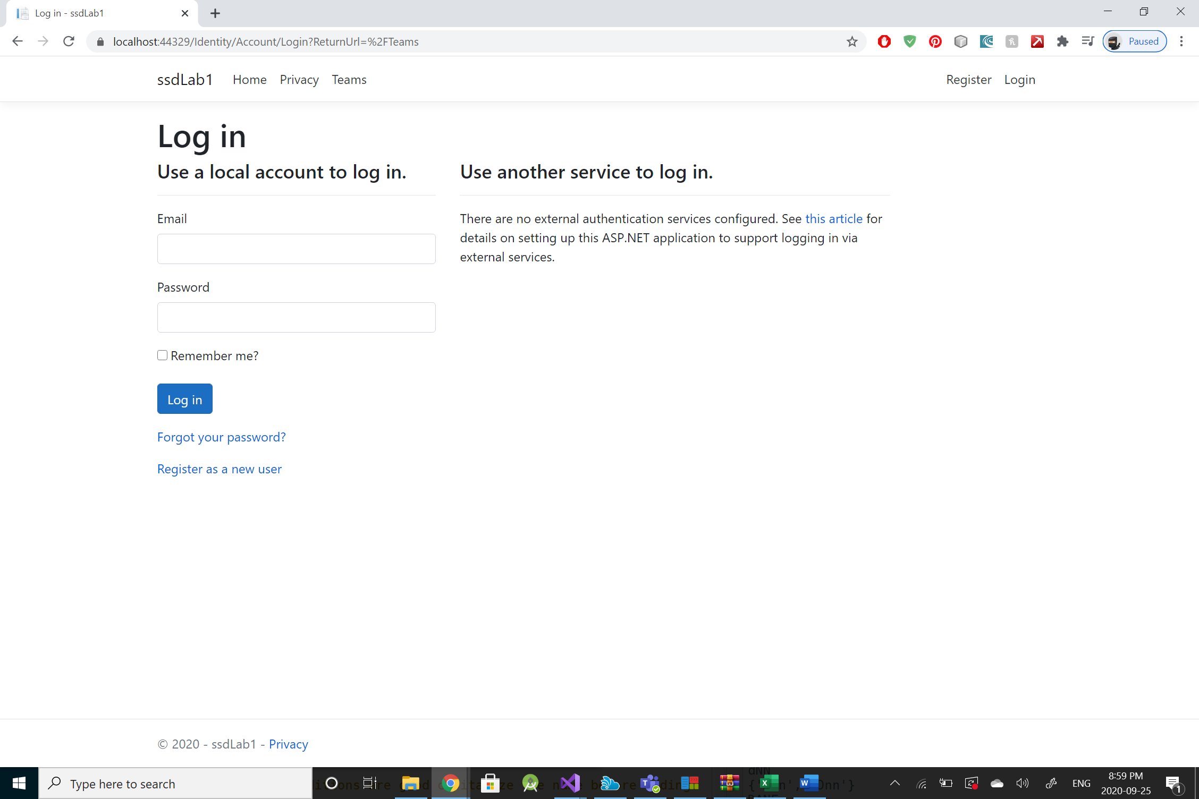

Figure 3 Unauthorized User trying to view the Team Index

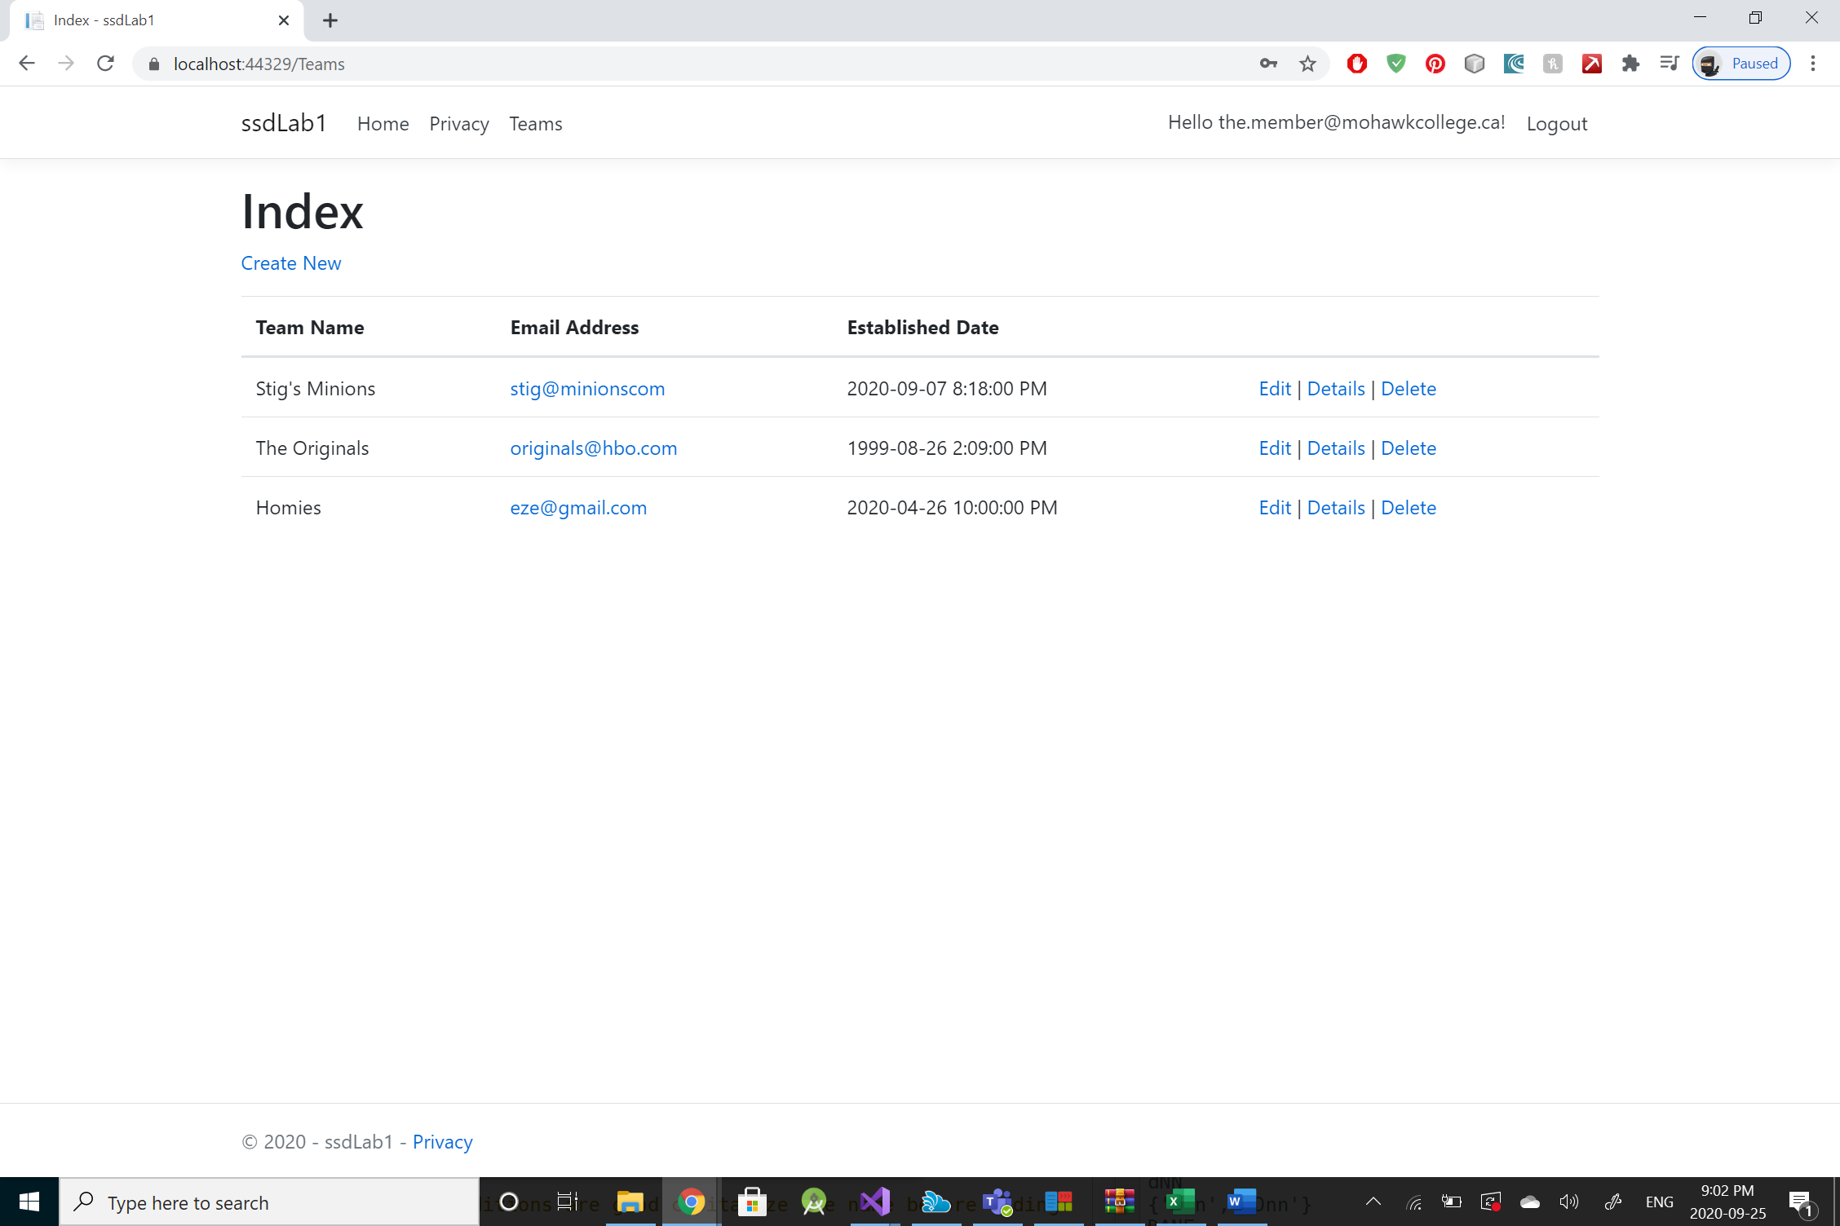

Figure 4 Member User Viewing Teams

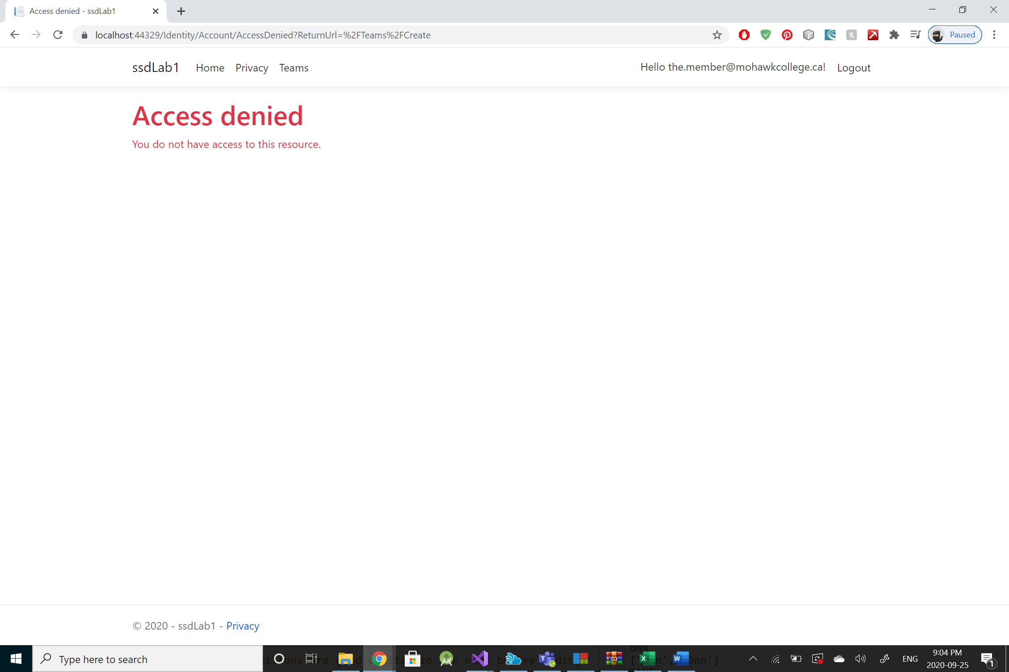

Figure 5 Access Denied when Member User attempts creating a team